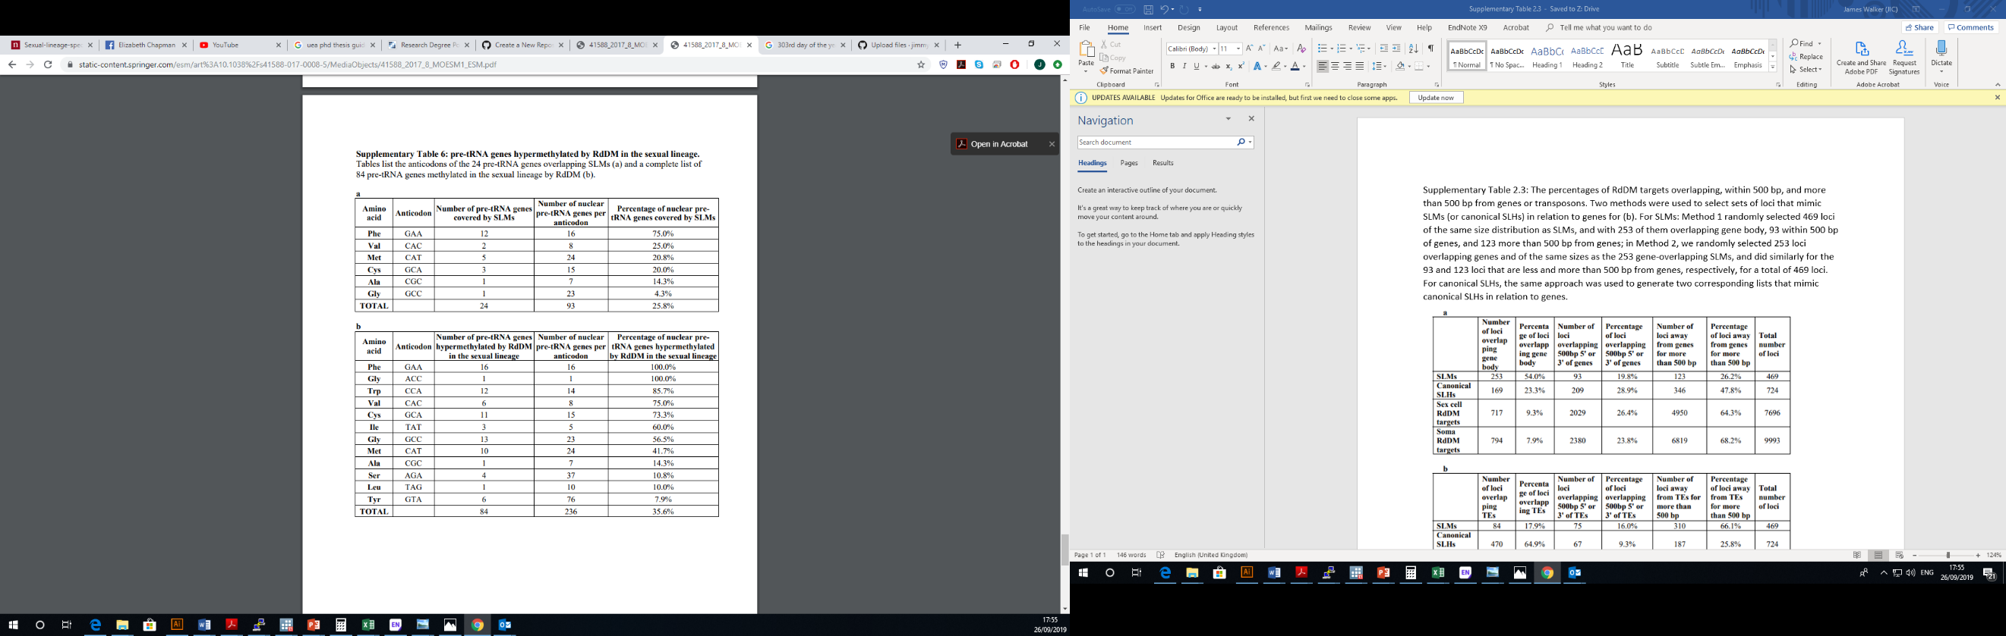Supplementary Table 2.6: pre-tRNA genes hypermethylated by RdDM in the sexual lineage. Tables list the anticodons of the 24 pre-tRNA genes overlapping SLMs (a) and a complete list of 84 pre-tRNA genes methylated in the sexual lineage by RdDM (b).